Random forest classifier for bank marketing
CSY3081 - AI Concepts and Applications
Joanne Uwera
Student ID:22810681
Table of Contents
1. Introduction 2
2. Methodology 3
2.1 Dataset Description 3
2.2 Exploratory Data Analysis 3
2.3 Data Pre-processing 4
2.4 Machine Learning Models 5
2.5 Out-Of-Bag Evaluation 6
2.6 Evaluation Metrics 6
3. Experiments and Results 7
3.1 Baseline Model Results 7
3.2 Random Forest Results 7
3.3 OOB Hyperparameter Tuning 8
3.4 Comparison With and Without Duration 8
3.5 Feature Importance Analysis 9
4. Discussion 11
4.1 Class Imbalance 11
4.2 Ethical Considerations 11
4.3 Limitations 11
5. Conclusion 12
References 13

Figure 1 Target Variable Distribution 3
Figure 2 Age Distribution 4
Figure 3 Job Subscription Rate 4
Figure 4 OOB Tuning Results 8
Figure 5 Model Performance Comparison Table 9
Figure 6 Model Performance Comparison 9
Figure 7 Feature Importance Without Duration 9

Introduction
Machine learning and artificial intelligence are being used more frequently to improve decision making and customer relationship management within the banking industries. One important application is direct marketing, this is where banks attempt to predict whether a customer will subscribe to a financial product such as a term deposit. Having accurate prediction models helps reduce marketing costs, improve customer targeting and increase campaign success rates for these banks (Fitriani and Febrianto, 2021) .
The project aim is to use the bank marketing dataset to develop a random forest classifier that predicts whether a client will subscribe to a bank term deposit. The dataset contains information collected from direct marketing campaigns by a Portuguese banking institution between 2008 and 2010. It includes campaign related, financial and demographic attributes. The target variable is binary, representing whether the customer subscribed to a term deposit with “yes” or “no”.
The main goal of this project is to design, implement and evaluate a machine learning model capable of performing accurate predictions on unexplored data. Also, to investigate the effects of different hyperparameter settings on model performance using Out-of-Bag evaluation. Pre-processing techniques such as handling categorical variables and missing values will be applied to prepare the data for machine learning.
Random forest was the selected model because it is an ensemble learning algorithm which is capable of handling both numerical and categorical data while reducing overfitting through using multiple decision trees (Pranali Dhawas et al., 2023). The performance of the model is evaluated using metrics including accuracy, precision, recall, F1-score and confusion matrix analysis.

Methodology

Dataset Description
The dataset used in this project is the bank marketing dataset, which contains 41,188 records and 20 input features plus one output variable. Each row represents a client, while the columns describe customer characteristics and information. The target variable y indicates whether the client subscribed to a term deposit: “yes” means they’ve subscribed, no means they’ve not subscribed.
The dataset contains both numerical and categorical attributes. Examples of numerical features are:
- Age
- Campaign contacts
- Euribor rate
- Consumer confidence index
Examples of categorical features are:
- Job type
- Marital status
- Education
- Contact type
The dataset contains a large number of observations which makes it suitable for training machine learning models . However, one important feature in the dataset is duration, which represents the duration of the last phone call. According to the dataset documentation, this feature influences the output and would not be available before making a prediction in a real-world scenario so the final test should be without duration included.

Exploratory Data Analysis
Exploratory data analysis was performed to better understand the dataset and identify important patterns.
Several visualisations were created, including:
- Distribution of the target variable.
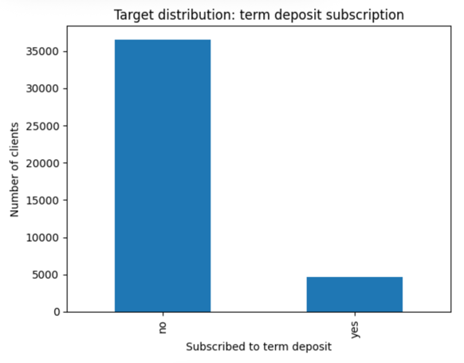
Figure 1 Target Variable Distribution
- Age distribution histogram.
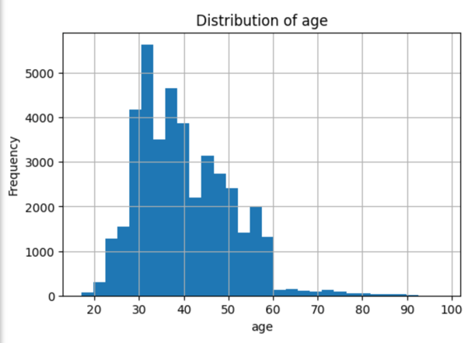
Figure 2 Age Distribution
- Subscription rates by Job.
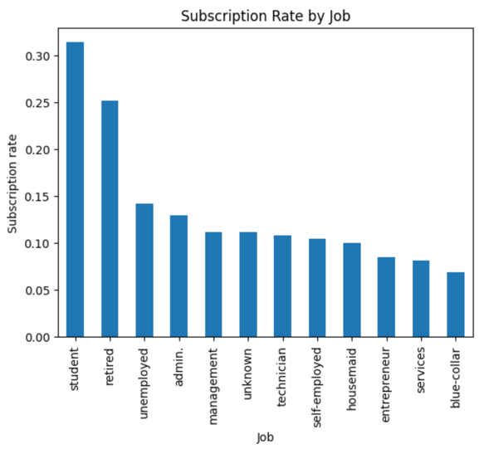
Figure 3 Job Subscription Rate
The analysis showed that the dataset is heavily imbalanced, with most customers not subscribing to the term deposit. It was also observed that some economic indicators and campaign-related features may strongly influence customer behaviour.

Data Pre-processing
Data pre-processing is a crucial stage in machine learning because raw data often contains missing values and unsuitable formats for modelling.
The dataset did not contain traditional missing values. However, some categorical features used the label “unknown” to represent missing information. These values were replaced with NaN values and filled using mode imputation because they may contain useful information for prediction as categorical features can’t be averaged. 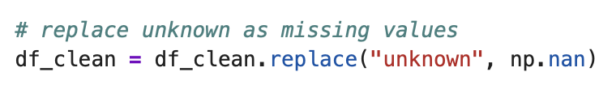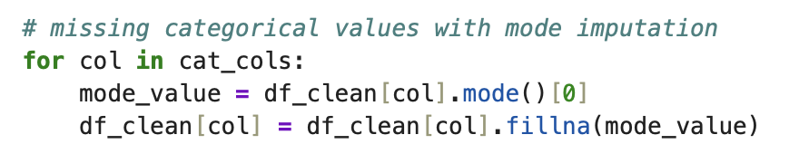
Machine learning models require numerical input values. Therefore, categorical variables were converted into numerical format using one-hot encoding through the pandas get_dummies() function.
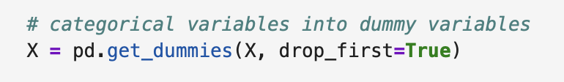
The dataset was divided into training and testing sets using an 80:20 ratio. The training set was used to build the models, while the testing set was used to evaluate model performance on unseen data. 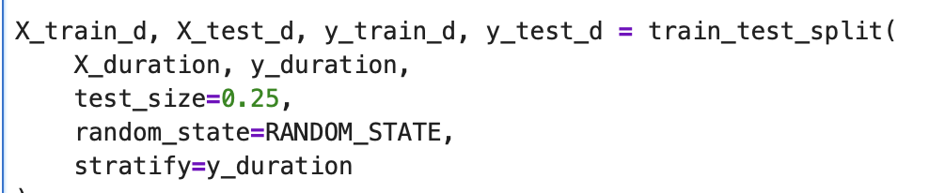
The dataset is imbalanced because the number of customers who did not subscribe is much larger than the number who subscribed. To reduce bias towards the majority class, the class_weight='balanced' parameter was used in the Random Forest model. This automatically adjusts the weights assigned to classes during training.

Machine Learning Models
Logistic regression was implemented as a classification model. It predicts probabilities using a linear relationship between input variables and the target variable. Although it is efficient and interpretable, it can struggle to capture other complex non-linear relationships.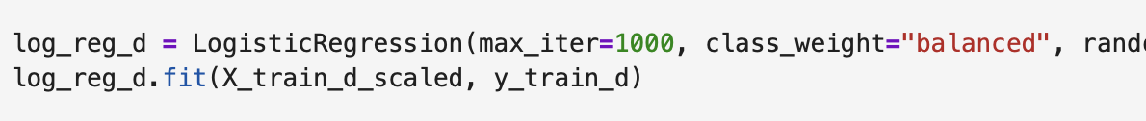
A decision tree classifier was implemented to compare its performance with the random forest model. As decision trees split data into branches using feature-based conditions however they are easy to interpret but can experience overfitting.
The main model used in this project was the random forest classifier. Random forest combines multiple decision trees using bagging and random feature selection. Each tree is trained on a different sample of the training data. This approach provides several advantages:
- Reduces overfitting.
- Improves generalisation.
- Handles non-linear relationships.
- Works effectively with large datasets.
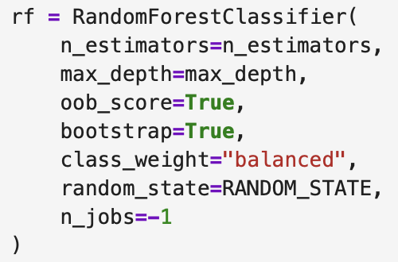

Out-Of-Bag Evaluation
Out-of-Bag (OOB) evaluation was used for model assessment and hyperparameter tuning.
In random forest, bootstrap sampling leaves out some training samples from each tree. These unused samples are called Out-of-Bag samples and can be used as a validation set.
Different random forest configurations were tested using varying numbers of estimators and tree depths. The model with the highest OOB score was selected as the final model.
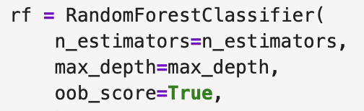

Evaluation Metrics
Several evaluation metrics were used:
- Accuracy
- Precision
- Recall
- F1-score
- Confusion Matrix
Accuracy measures overall prediction correctness whilst, precision measures how many predicted positive cases were actually positive. Recall measures how many actual positive cases were identified correctly whereas, F1-score balances precision and recall (Selim, Ali and Ristevski, 2024). The confusion matrix provides a detailed breakdown of classification performance.
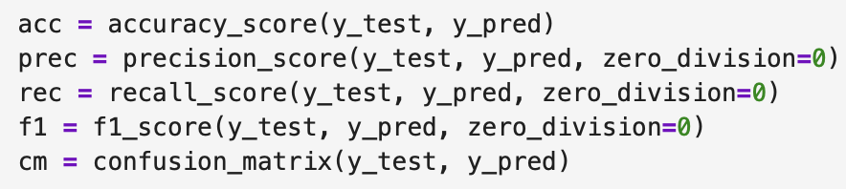

Experiments and Results

Baseline Model Results
The logistic regression model achieved an accuracy of 86.43%.
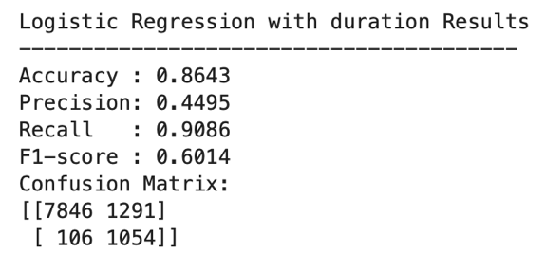
The confusion matrix showed that the model correctly classified most customers who did not subscribe at 7846 while also identifying a high proportion of customers who did subscribe at 1054. However, the precision score was relatively low, indicating that the model produced many false positive predictions which you can see was 1291.
The decision tree classifier achieved an accuracy of 85.55%.
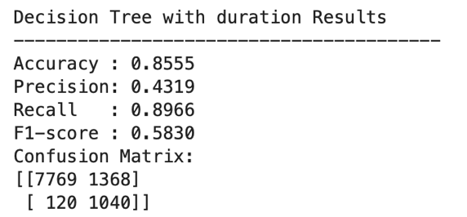
The decision tree achieved similar recall performance to logistic regression but slightly lower overall accuracy and F1-score. The model also showed signs of overfitting because decision trees can become overly complex when trained on large datasets. The confusion matrix showed quite similar results as logistic regression with sightly higher false positives and false negatives.
Overall, both baseline models performed reasonably well but struggled to achieve balanced precision and recall.

Random Forest Results
The Random Forest classifier achieved the strongest overall performance among all implemented models. The Random forest model achieved:
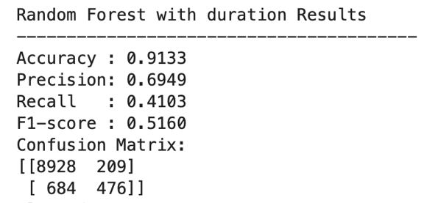
The confusion matrix showed:
- True Negatives: 8928
- False Positives: 209
- False Negatives: 684
- True Positives: 476
Compared with logistic regression and decision trees, the random forest model achieved much higher accuracy and precision. The model was significantly better at avoiding false positive predictions, which improved overall reliability. However, the recall score decreased because the model became more stricter when predicting positive subscription cases.
Although the F1-score was slightly lower than logistic regression, the random forest model produced more balanced and realistic predictions overall. This is due to the ensemble learning approach reducing overfitting compared with the single decision tree model.

OOB Hyperparameter Tuning
Several combinations of hyperparameters were tested using different numbers of estimators and tree depths. The best model configuration was:
- n_estimators = 300
- max_depth = None
- Best OOB score = 0.9111
The OOB tuning results showed that increasing the maximum tree depth improved performance significantly.
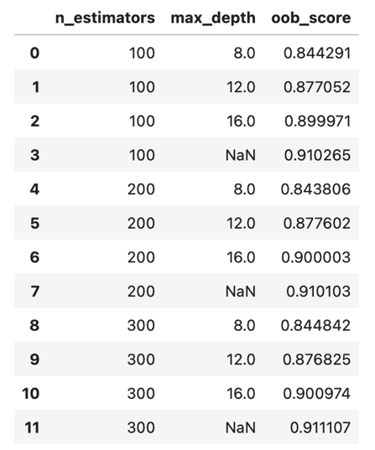
Figure 4 OOB Tuning Results
Increasing the number of trees also slightly improved performance stability. The best performing model used 300 trees with unrestricted depth. Demonstrating that deeper trees were more able to capture complex relationships within the dataset compared to the fixed depth of 8, 12 or 16.

Comparison With and Without Duration
Two Random Forest models were created for experimentation:
- First model including the duration feature.
- Second model excluding the duration feature.
The model including duration achieved significantly higher accuracy, precision, recall and F1-score. However, the dataset documentation states that call duration is only known after a call has finished.
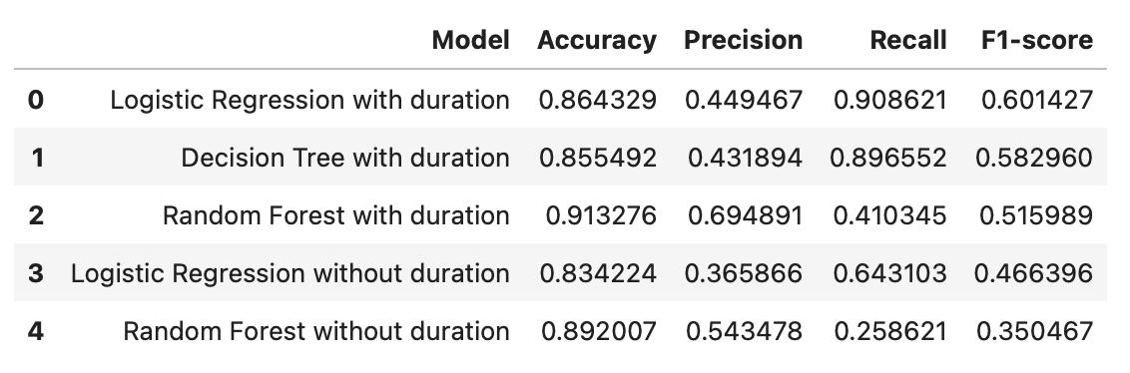
Figure 5 Model Performance Comparison Table
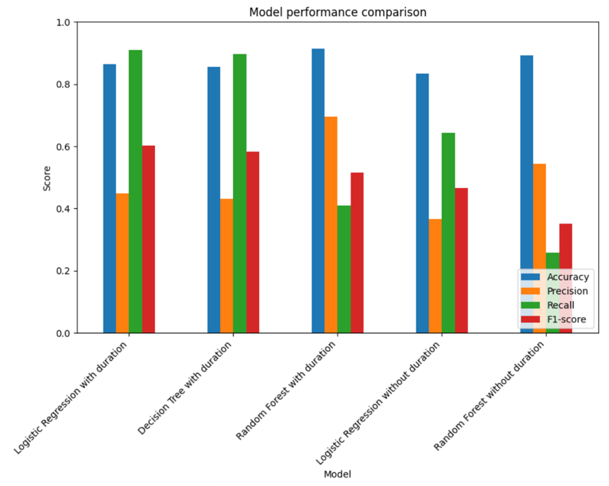
Figure 6 Model Performance Comparison
These results show that removing duration reduced overall predictive performance, particularly recall and F1-score. However, the model without duration represents a more realistic business scenario because the feature would not be available before customer contact so moving forward feature importance was taken from the random forest model without duration. This experiment demonstrates the importance of avoiding data leakage in machine learning systems.

Feature Importance Analysis
Feature importance analysis identified the variables that most strongly influenced prediction outcomes which was age.
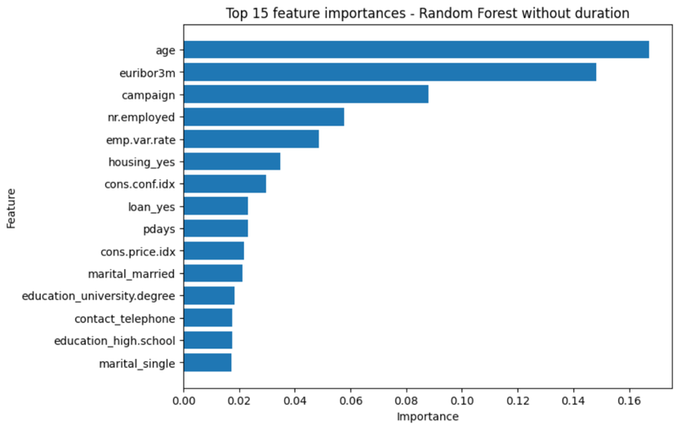
Figure 7 Feature Importance Without Duration
Other important variables included euribor3m, campaign, nr.employed, and emp.var.rate. Within the random forest model with duration, the duration feature had the highest importance score by a large margin, which further supports the observation that it strongly affects prediction performance in comparison to the model without. The economic attributes such as euribor3m and nr.employed are influential because they may reflect larger economic conditions that can affect the customers decisions.

Discussion
The results demonstrate that random forest is effective for classification tasks involving both numerical and categorical data. Compared with logistic regression and decision trees, the random forest classifier achieved better and more balanced performance. One important reason for the improved performance is ensemble learning. Instead of relying on a single decision tree, random forest combines predictions from many trees. This reduces spread and improves stability. The use of OOB evaluation was also beneficial because it provided an efficient method for model validation without requiring a separate validation dataset. However, the project also revealed several challenges.

Class Imbalance
The dataset imbalance made it difficult to correctly predict customers who subscribed to the term deposit. Although class weighting improved performance, some minority-class cases were still classified incorrectly.
Future work could investigate alternative balancing techniques such as:
- SMOTE
- Under sampling
- oversampling

Ethical Considerations
AI systems used in banking and marketing must be applied responsibly. Ethical considerations should be taken such as bias and fairness, machine learning models can discriminate against minor demographic groups if the dataset already contains bias. Interpretability, even though random forest models are powerful, they are less interpretable than simpler models such as logistic regression. customers financial and personal information must be protected following the data protection regulations. Transparency, businesses should understand how predictions are generated before using AI systems for decision-making otherwise there could be a confusion and a lack of trust when it comes to the results and usability.

Limitations
Despite the positive results, the project has several limitations:
- Limited hyperparameter tuning.
- Imbalanced dataset, subscriptions and no subscriptions.
- Reduced interpretability compared to simpler models.
Future improvements could include:
- Cross-validation.
- Alternative ensemble methods.
- Explainable AI techniques.
- Additional hyperparameter tuning

Conclusion
This project successfully implemented machine learning models to predict whether bank clients would or would not subscribe to a term deposit.
Three classification algorithms were implemented, including logistic regression, decision tree and random forest classifiers. Compared to all models, the random forest classifier achieved the best overall performance, reaching an accuracy of 91.33% when the duration feature was included.
Effective data pre-processing, handling of missing categorical and numerical values as well as dealing with class imbalance is important for having stable and reliable results. Out-Of-Bag evaluation also was important when selecting several combinations of hyperparameters to test performance.
The experimentations that occurred portrayed that logistic regression and decision trees achieved high recall scores, therefore they had a large number of clients who subscribed to the term deposit. However, these models also produced a large number of false positive predictions. Whereas the random forest classifier achieved much a higher precision and overall accuracy therefore producing more reliable predictions also whilst reducing overfitting through ensemble learning.
The comparison between models trained with and without the duration feature was important. When including duration, it improved the random forests predictive performance because it was the most influential feature in the dataset as stated. However, since call duration is only known after a customer interaction has finished it would be unrealistic to use in the real world and cause data leakage. Therefore, the model without duration provides a more realistic representation of how machine learning could be applied in a real banking environment and was then used for final feature importance.
This project portrayed how machine learning helps with decision making choices within banking and marketing industries.

References
- Fitriani, M.A. and Febrianto, D.C. (2021). Data Mining for Potential Customer Segmentation in the Marketing Bank Dataset. JUITA: Jurnal Informatika, 9(1), p.25. doi:https://doi.org/10.30595/juita.v9i1.7983.
- Pranali Dhawas, Minakshi Ashok Ramteke, Thakur, A., Poonam Vijay Polshetwar, Ramadevi Vitthal Salunkhe and Bhagat, D. (2023). Big Data Analysis Techniques. Advances in business information systems and analytics book series, pp.183–208. doi:https://doi.org/10.4018/979-8-3693-0413-6.ch007.
- ‌Selim, A., Ali, I. and Ristevski, B. (2024). University Information System’s Impact on Academic Performance: A Comprehensive Logistic Regression Analysis with Principal Component Analysis and Performance Metrics. TEM Journal, [online] pp.1589–1598. doi:https://doi.org/10.18421/tem132-72.
- UCI Machine Learning Repository. Bank Marketing Dataset.

